Point 7: In addition to the GMAO backup, one must take into account the time needed for the transfer across the network of the backup file on the server GMAO 1 and GMAO2 (approx. 1h: 30 between TATA Prod and SATIN Preprod. with the use of the admin card)
Point 8: The destination database for the management of the maintenance assisted by the computer (GMAO) already existed, (offline attempts for a period of 2 hours) >stopping of the procedure before « offline » development and renaming of the restoration path of the secondary databases,
Point 8b: The restoration of the GMAO1 has worked, but the suppression of the secondary database is not possible because it is not empty.
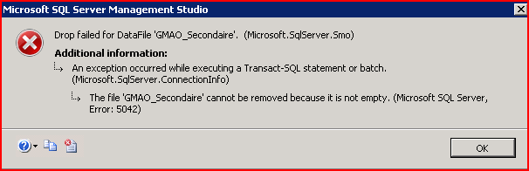
How to empty it prior to suppression, because it has not been indicated in the PTI?
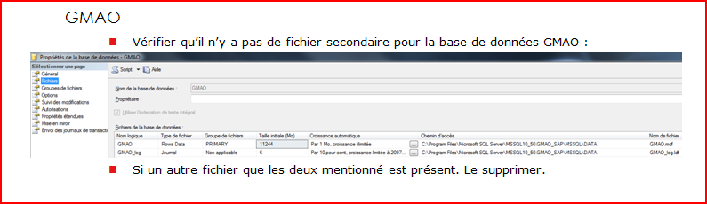
- Reclamation and recovery of the document SATIN_MODE_OPE_Suppression_file_secondaire.docx
- The « shrink » necessary before the suppression of the secondary database took one hour (1H).

Point 8c Point 9c
We have the following errors during the installation stage of the import tools on GMAO1 during the launching of the installation script SATIN-Install-GMAO.ps1 delivered with the package.
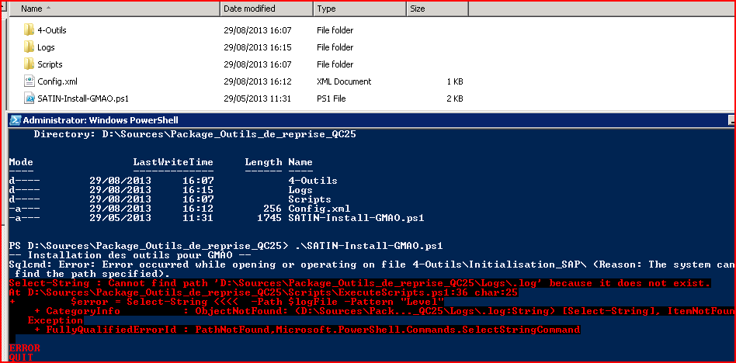
It necessitates a resupply of TMA part.
In the package which you have sent me, there are no scripts in the 4-Tools\Initialisation_SAP\ directory.
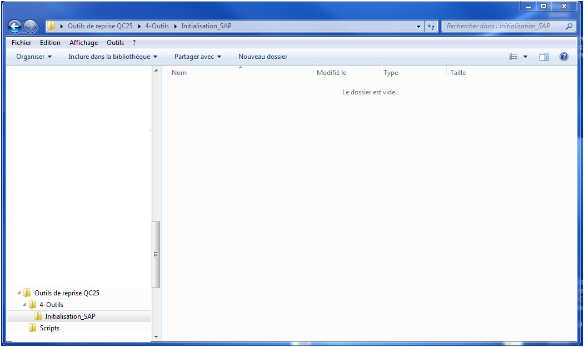

There should be the scripts as described below:
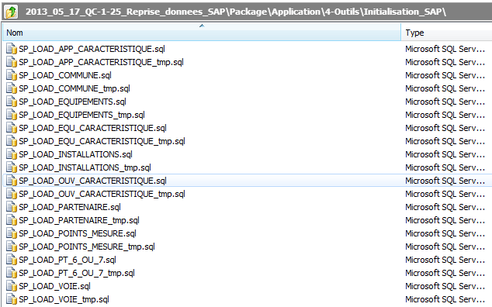

Problem of the passage of the instructions, the account password was not recognised.
<Config>
<sqlserver>
<server>GMAO1-PREPROD</server>
<instance>GMAO1</instance>
<login>sa</login>
<password>GDF1234!</password>
<domaine>USER_DOMAIN</domaine>
</sqlserver>

<gmao>
<database>GMAO</database>
</gmao>
</Config>

Pour GMAO2, the first SQL script is an error, a cause for the timeout. The
The workaround procedure is not mentioned.

Point 13b: To check that the tables are empty, I have manually started the following query for each table:

« Select * <NOM_TABLE> »
- Shouldn’t there be-a SQLscript provided to accelerate this task?

Point 17 Duplicate error during the import of the VOIE.csv file on GMAO2
- A 2nd stream of the table VOIE was necessary.
- The launch of the request process for the import of the file cannot be scripted for the launch of the 10 requests of interceptions?

Point 17b: In the actions to be done, the GMAO CTR restoration has not been mentioned and the document necessary for it has been recovered much later.

